# Intro

I will start with explanation basic concepts.

## Libraries

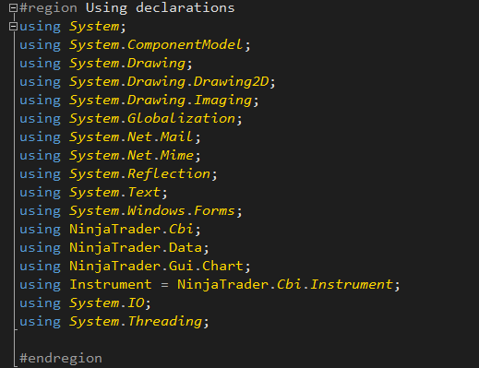

Those are libraries needed to make our code work.

In simple words without them our program cannot work with Ninja Trader, Mails, Windows Forms, Multithreading and so on….

In the beginning of each library you can see to which namespace it’s belong

System mean it’s belong to the .Net framework

Ninja Trader mean that it belong to the Ninja Trader Library

# ChartSlopeTrader.cs